
DELHI PUBLIC SCHOOL, HAPUR
Session 2025 – 26
Ramanujan Math Spark Competition
Class -III
RESULT DECLARATION

Name of the student | Section | Winner |  | Position
Aadhya Agarwal | C | 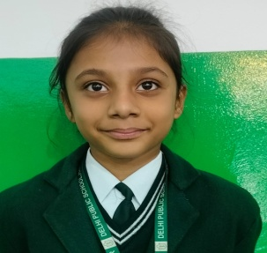 |  | First
Himaira  Gaba | C | 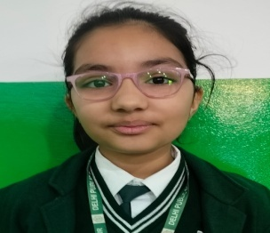 |  | First
Naomika  Arora | C | 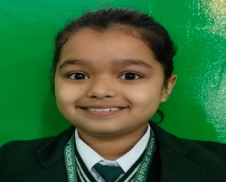 |  | First
Rudra Cheema | C | 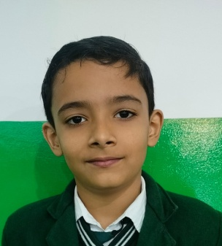 |  | First
Medhansh Bhati | D |  |  | Second
Shivansh Tyagi | D |  |  | Second
Meet Gaba | D | 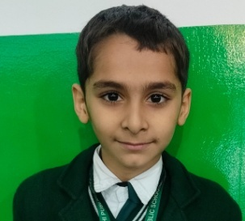 |  | Second
Kunal  Sehgal | D | 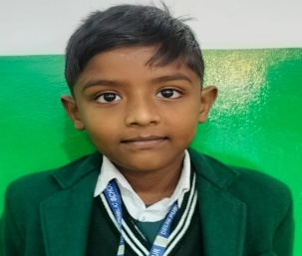 |  | Second
Amayra Karanwal | A | 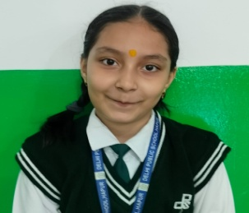 |  | Third
Anaya Karanwal | A | 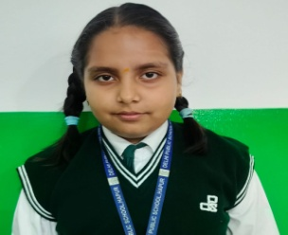 |  | Third
Khyati Gaur | A | 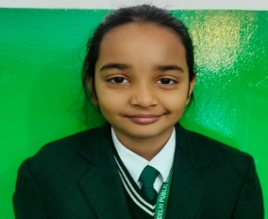 |  | Third
Yuvraj Sharma | A |  |  | Third

